**K-means Clustering Code – OUTPUT**

**Clustering Vectors & Identification**

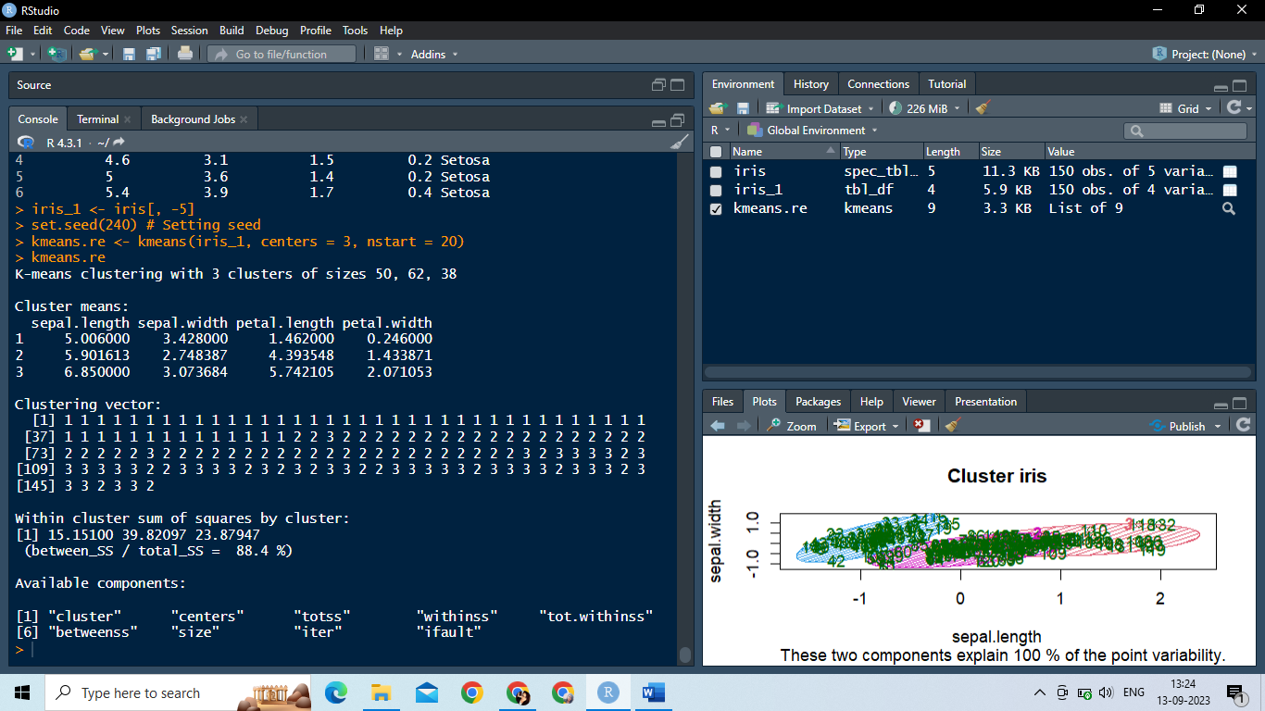

**Confusion Matrix**

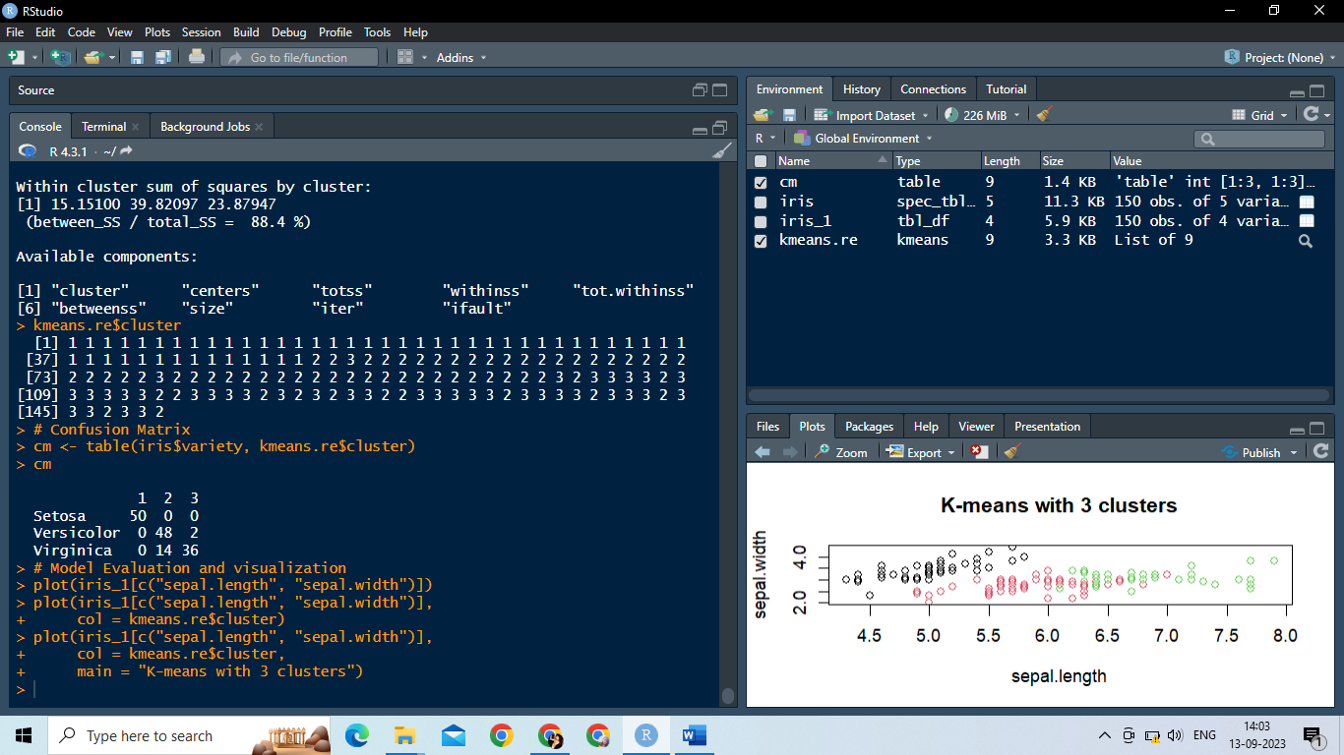

**Model Evaluation and visualization**

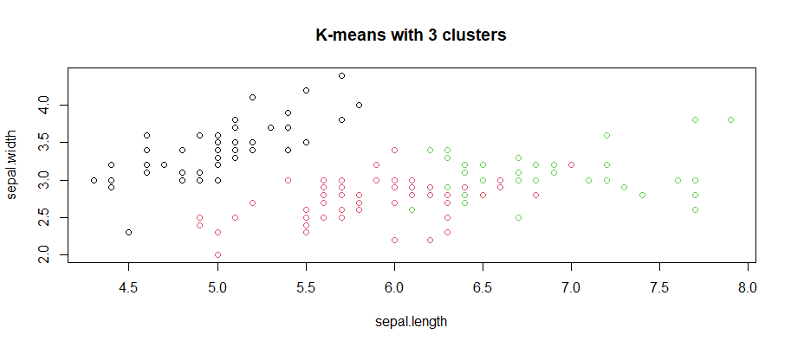

**Plotting cluster centers**

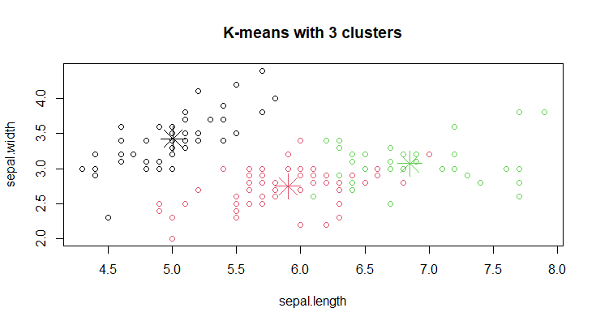

**Visualizing clusters**

